Affiliated to Pokhara University
UNITED TECHNICAL COLLEGE

A MAJOR PROJECT FINAL REPORT
ON
Ayurvedic Intelligence: Revolutionizing Ayurveda with AI
[Code No: CMP 490]
(For partial fulfillment of 8th Semester in Computer Engineering)
Submitted By:
Ashish Agrawal [BEC-2021-1-07-0007]
Dipesh Shrestha [BEC-2021-1-07-0014]
Kiran Pokharel [BEC-2021-1-07-0018]
Sandesh Dharel [BEC-2021-1-07-0037]

Submitted To:
Department of Computer Engineering
2nd July, 2025

PROJECT WORK FOR THE DEGREE OF BACHELOR’S IN COMPUTER ENGINEERING

Ayurvedic Intelligence: Revolutionizing Ayurveda with AI

Supervised by Er. Pukar Neupane

A project work submitted in partial fulfillment of the requirements for the degree of bachelor’s in Computer Engineering

Ashish Agrawal [BEC-2021-1-07-0007]
Dipesh Shrestha [BEC-2021-1-07-0014]
Kiran Pokharel [BEC-2021-1-07-0018]
Sandesh Dharel [BEC-2021-1-07-0037]

United Technical College
Faculty of Science and Technology
Pokhara University, Nepal

July, 2025

DEDICATION
This project dedicated with sincere appreciation to our outstanding teachers, whose constant direction and mentoring have been crucial to our accomplishment. Their advice and support have been invaluable.
Light along the way, motivating us to strive for greatness. We also want to express our sincere gratitude to our parents, whose constant spiritual and financial support has kept us going as this initiative has grown. We have learned that even the most difficult jobs can be completed, one step at a time, thanks to their sacrifices, faith in our skills, and insightful life teachings. We will always be thankful to our devoted teachers and devoted parents, whose unflinching belief in us has been the foundation of our success.

DECLARATION
We hereby declare that this study entitled “Ayurvedic Intelligence: Revolutionizing Ayurveda with AI” is based on our original work. Related works on the topic by other researchers has been duly acknowledged. We owe all the liabilities relating to the accuracy and authenticity of the data and any other information included here under.

Name of the students:
Ashish Agrawal
Dipesh Shrestha
Kiran Pokharel
Sandesh Dharel

Date: July 2, 2025

RECOMMENDATION
This is to certify that this project work entitled “Ayurvedic Intelligence: Revolutionizing Ayurveda with AI”, prepared and submitted by Ashish Agrawal, Dipesh Shrestha, Kiran Pokharel, Sandesh Dharel in partial fulfillment of the requirements of the degree of Bachelor of Computer Engineering awarded by Pokhara University, has been completed under our supervision. We recommend the same for acceptance by Pokhara University.

Signature:
Name of the Supervisor: Er. Pukar Neupane
Organization: United Technical College
Date: July 2, 2025

CERTIFICATE

This project entitled “Ayurvedic Intelligence: Revolutionizing Ayurveda with AI”, prepared and submitted by Ashish Agrawal, Dipesh Shrestha, Kiran Pokharel, Sandesh Dharel has been examined by us and is accepted for the award of the degree of Bachelor in Computer Engineering by Pokhara University.

Name of External:  Designation: Engineer  Organization: | Signature: | Date:
Name of Supervisor: Er.Pukar Neupane  Designation: Engineer  Organization: United Technical College | Signature: | Date:
Name of Principal:  Prof. Madhav Prasad Koirala, Ph.D.  Organization: United Technical College | Signature: | Date:

ACKNOWLEDGEMENTS
It gives us great pleasure to acknowledge the several individuals who helped shape our project, either directly or indirectly, and who impacted our actions, attitudes, and ways of thinking during the project.
We want to sincerely thank United Technical College for helping us finish our project, "Ayurvedic Intelligence: Revolutionizing Ayurveda with AI" and for providing a conducive environment.
We would like to sincerely thank our college's principal, Prof. Madhav Prasad Koirala, for his encouragement, collaboration, and support during the project.
We would like to express our special thanks to our supervisor Er.Pukar Neupane for his time and efforts he provided throughout the project’s completion. In this aspect, we are eternally grateful to you.
We would like to acknowledge that this project was completed entirely by our group and not by someone else.
Thanks for all your encouragement!

Name of the Students:
Ashish Agrawal
Dipesh Shrestha
Kiran Pokharel
Sandesh Dharel
Date: July 2nd, 2025

ABSTRACT
The project aims to develop an AI-powered platform that integrates modern technology with traditional Ayurvedic knowledge to provide holistic health solutions. The system will utilize image recognition techniques to identify medicinal plants with high accuracy, supported by a curated dataset, and employ Natural Language Processing (NLP) to extract and summarize Ayurvedic remedies based on user symptoms. It will also offer comprehensive information on herbs, human disease analysis, personalized treatment recommendations, and provide Ayurvedic alternatives to modern medicine for ailments. Key features include an AI chatbot, Herbs recognition, diet planning, and wellness practices such as yoga and meditation. Leveraging AI models, local storage platforms, the system will be developed in collaboration with Ayurvedic experts, ensuring authentic and accurate recommendations. Ultimately, the project seeks to bridge the gap between modern and traditional healthcare, making Ayurvedic remedies more accessible while preserving and promoting ancient knowledge.
Keywords: AI-powered platform, Ayurvedic knowledge, Image recognition, Natural Language Processing (NLP), personalized treatment, Wellness practices

TABLE OF CONTENTS
PROJECT WORK FOR THE DEGREE OF BACHELOR’S IN COMPUTER ENGINEERING ii
DEDICATION iii
DECLARATION iv
RECOMMENDATION v
CERTIFICATE vi
ACKNOWLEDGEMENTS vii
ABSTRACT viii
TABLE OF CONTENTS ix
LIST OF FIGURES xii
LIST OF TABLES xiii
ACRONYMS AND ABBREVIATION xiv
Chapter 1: INTRODUCTION 1
1.1 Background 1
1.2 Statement of Problem 2
1.3 Research Questions 2
1.4 Objectives 3
1.5 Motivation and Significance 3
1.6 Scope of Work 3
Chapter 2: RELATED WORKS 4
2.1. Overview of Existing Systems 4
2.1.1. Patanjali 4
2.1.2. AyuRythm 4
2.1.3. AIwell 5
2.1.4. Nepal Ayurveda 5
2.1.5. AyuCare 5
2.2. Comparison of Features 6
2.3. Gaps in Existing Systems 7
2.4. Significance of Proposed Work 7
Chapter 3: METHODOLOGY 8
3.1 Requirements Gathering 8
3.2 System or Model Design 9
3.2.1 Image Classification 9
3.2.2 AI powered Chatbot 11
3.2.3 Overall Framework 12
3.2.4 Core Components 12
3.3 Technology Stack 13
3.3.1 Platform: Google Colab 13
3.3.2 Storage: Google Drive 13
3.3.3 Programming Language: Python 13
3.3.4 Deep Learning Framework: PyTorch 13
3.3.5 Computer Vision Toolkit: torchvision 13
3.3.6 Pretrained Model: ResNet-18 14
3.3.7 Image Handling: PIL (Python Imaging Library) 14
3.4. Data Management 14
3.5 Model Evaluation 15
3.5.1 Training and validation matrices 15
3.6 Software Development Process 23
3.6.1. Identify/Research: 23
3.6.2. Project Preparation: 23
3.6.3. Design: 24
3.6.4. Execution: 24
3.6.5. Sustain: 24
3.6.6. Monitor: 24
3.7 Version Control 25
3.8 Collaboration and Task Management 25
Chapter 4: RESULT AND DISCUSSION 26
4.1. Outcome 26
4.2 Achieved Outcomes 26
4.2.1 Web Application Functionality 26
4.2.2 Chatbot Implementation 26
4.2.3 Herbal Image Classifier (Initial Version) 27
4.2.4 Patient Login System 28
4.2.5 Homepage and Navigation 29
4.2.6 Yoga, Meditation and Diet 29
Chapter 5: CONCLUSION AND FUTURE ENHANCEMENT 31
5.1 Future enhancements for the project include: 32
REFERENCES 33
APPENDICES 34
Gantt chart: 34
Cost estimation: 34

LIST OF FIGURES
Figure 1: Image Classification 9
Figure 2: AI powered Chatbot 11
Figure 3: Dataset Used 14
Figure 4: Precision-Confidence Curve 15
Figure 5: Precision Recall Curve 16
Figure 6: Bleu Score 17
Figure 7: Confusion Matrix 18
Figure 8: Average Precision 19
Figure 9: Training Loss over Epochs 20
Figure 10: Training Accuracy over Epochs 21
Figure 11: Pair Plot over classes 22
Figure 12: SDLC (Group Work) 23
Figure 13: Chatbot 27
Figure 14: Image Identifier 27
Figure 15: Image Identified 28
Figure 16: Login Page 28
Figure 17: HomePage 29
Figure 18: Yoga 30
Figure 19: Meditation Techniques 30

LIST OF TABLES
Table 2.1: Features and Drawbacks………………..……………………..……….6
Table 6.2: Cost Estimation……………………………………………………….34

ACRONYMS AND ABBREVIATION
ÁI Ayurvedic Intelligence
AI Artificial Intelligence
API Application Programming Interface
CNN Convolutional Neural Network
CSS Cascading Style Sheets
GPU Graphics Processing Unit
HTML HyperText Markup Language
JS JavaScript
ML Machine Learning
MYSQL MySQL (Structured Query Language)
NLP Natural Language Processing

Chapter 1: INTRODUCTION

1.1 Background
Ayurveda, a traditional system of medicine, has long been an integral part of healthcare in Nepal, with a rich heritage of utilizing medicinal plants for various therapeutic purposes. Recent developments in the field of Ayurvedic medicine in Nepal have focused on integrating modern technology with traditional knowledge. This includes the increasing use of AI to enhance the identification and analysis of medicinal plants. AI-based projects, particularly those using machine learning algorithms, can scan herbal plants, identify them, and provide accurate analysis and potential remedies based on centuries of traditional knowledge and modern pharmacological research. This convergence of technology and tradition holds immense promise in improving the accessibility and effectiveness of Ayurvedic treatments (Ripu M Kunwar, 2010).
Recent trends indicate a growing interest in AI-driven systems that can digitize and catalog the diverse medicinal plants of Nepal, many of which are integral to local healing practices. With the increasing exploitation of medicinal plants in Nepal for commercial purposes, especially through the export trade there is a critical need for AI systems to assess plant health, track sustainability, and ensure the preservation of biodiversity. AI technologies could also assist in evaluating the pharmacological potential of these plants, as discussed in various studies on traditional herbal medicine in Nepal, where researchers are keen to discover new applications for these plants in combating modern health issues like COVID-19 (Dipak Khadka, 2021).
However, there are certain drawbacks and challenges that must be addressed. The existing works on AI-based plant identification systems in Nepal often lack a comprehensive database of regional medicinal plants, which limits the AI’s ability to offer precise remedies. Additionally, there is a need to integrate ethnobotanical knowledge from diverse ethnic groups in Nepal to enhance the accuracy of AI-generated solutions. Furthermore, while AI-based systems hold significant promise, the lack of standardization and validation of these remedies against scientific research remains a major hurdle. The growing concerns over the use of fixed-dose herbal combinations, as noted in some studies, also highlight the necessity for a careful approach when developing AI-driven solutions to ensure safety and efficacy. Thus, while AI-based plant identification systems offer an exciting avenue for enhancing Ayurvedic practices in Nepal, addressing these gaps will be crucial for their successful implementation and acceptance (Arjun Poudel, 2016).

1.2 Statement of Problem
The Ayurvedic herbal medicine project faces challenges such as:
- Limited accessibility to herbal knowledge and Ayurvedic practices.
- Difficulty in offering personalized health recommendations.
- Lack of integration between traditional Ayurveda and modern technology.
ÁI aims to resolve these by using AI for herb identification, NLP for personalized remedies, and Ayurvedic health assessments, combining ancient wisdom with modern tech to provide a reliable and personalized health solution.

1.3 Research Questions
- How accurately can a deep learning model like ResNet-18 classify region-specific medicinal plants using image data?
- To what extent can an AI-powered chatbot improve accessibility and understanding of traditional Ayurvedic knowledge among general users?
- What challenges arise when applying AI to Ayurveda in Nepal?

1.4 Objectives
The main objectives of the project includes:
- To provide people with insights into Ayurvedic medicine, its practices, and benefits through an intuitive, easy-to-use interface.
- To leverage AI to offer personalized recommendations for health.
- To provide personalized yoga, diet, and meditation plans, making holistic Ayurvedic care easily accessible.

1.5 Motivation and Significance
The limitations of traditional Ayurvedic practices, such as limited access to accurate herb identification and personalized health recommendations, motivate the need for modernization. This project aims to integrate AI with Ayurvedic knowledge to enhance accessibility and provide reliable, personalized solutions. By using AI for plant identification, NLP for remedy suggestions, and Ayurvedic health assessments, the system will bridge the gap between ancient wisdom and modern technology. The proposed solution has significant implications for improving Ayurvedic healthcare, making it more accessible, efficient, and personalized for users, while preserving traditional knowledge and practices.

1.6 Scope of Work
The scope of this project includes the following:
- Development of an AI-powered system for identifying medicinal herbs through image recognition.
- Integration of Natural Language Processing (NLP) for personalized Ayurvedic remedy suggestions based on user symptoms.
- Implementation of a user-friendly interface for easy navigation and interaction.

Chapter 2: RELATED WORKS

2.1. Overview of Existing Systems
Existing Ayurvedic health systems like Patanjali, AyuRythm, AIwell, Nepal Ayeveda, and AyuCare offer various features, including product offerings, personalized health solutions, and expert consultations. However, they have limitations such as regional availability, lack of scientific validation, privacy concerns, and technical issues. These gaps highlight the need for a system that combines traditional Ayurvedic knowledge with modern technology, improving accessibility, personalization, and reliability.

2.1.1. Patanjali
Patanjali, founded in 2006 by Baba Ramdev and Acharya Balkrishna, is a well-known Indian brand offering a wide range of Ayurvedic products, including herbal medicines, personal care items, and food products. Known for its focus on natural ingredients and affordability, Patanjali has established itself as a household name with an extensive distribution network across India. The company integrates traditional Ayurveda with modern production techniques to ensure quality and accessibility to consumers globally (Singh, 2016).

2.1.2. AyuRythm
The app is designed to offer personalized Ayurvedic health solutions, enabling users to integrate Ayurveda into their daily lives. It provides tailored recommendations for diet, lifestyle, and wellness practices based on individual doshas (body constitutions). AyuRythm also includes features like access to a wide range of Ayurvedic remedies, consultations with expert practitioners, and educational content on Ayurvedic medicine. This app aims to make Ayurvedic knowledge more accessible, supporting users in achieving a balanced and holistic lifestyle (Monthly Ayurveda Bulletin, 2019).

2.1.3. AIwell
AIwell was launched in 2022 by Ayur.AI as an integrative health app that combines Ayurveda with modern medicine. It offers personalized health assessments and wellness plans based on individual Ayurvedic doshas, integrates wearable devices for real-time health monitoring, and provides access to a network of health experts. AIwell aims to bridge traditional healing practices with modern technological advancements to provide a comprehensive wellness experience (AI Well, n.d.).

2.1.4. Nepal Ayurveda
Nepal Ayurveda is a mobile app developed by TechKharkhana to make Ayurvedic healthcare more accessible to the Nepalese population. It allows users to book appointments with certified Ayurvedic doctors, purchase Ayurvedic products, and access wellness information based on traditional healing practices. The app offers personalized health recommendations, information on Ayurvedic herbs, and a marketplace for purchasing wellness products. While it emphasizes user privacy, some users have reported technical issues and difficulties with navigation, but the app remains a valuable tool for integrating Ayurvedic practices into modern healthcare (Trxrsop, 2024).

2.1.5. AyuCare
Ayurcare is an Ayurvedic wellness center in Dubai, offering a wide range of traditional Ayurvedic treatments such as relaxation therapies, weight loss therapies, detox, skin and hair care, and joint care. They also provide specialized treatments for pregnancy care, eye care, and disease-specific therapies. The center has over two decades of experience in delivering authentic Ayurvedic services and is dedicated to promoting holistic wellness (ayurcare, 2025).

2.2. Comparison of Features
Table 1: Features and Drawbacks
Platform | Features | Drawbacks
AIwell | Health assessments based on Ayurvedic doshas.  Integration with wearable devices for monitoring. | Limited regional availability.  Privacy concerns with data usage.
Ayurythm | Rhythm-based Ayurvedic therapies.  Personalized guided therapy sessions. | Niche appeal.  Limited scientific backing for some therapies.
Patanjali | Wide range of Ayurvedic products.  Affordable pricing and strong distribution. | Quality control issues.  Limited international availability.
Ayucare | Online Ayurvedic consultations.  Personalized health plans. | Dependent on internet connectivity.  Generic advice without deep personalization.
Nepal Ayurveda | Provides Ayurvedic consultations and herbal remedies.  Focuses on traditional Nepalese healing practices | Limited technological features compared to global platforms.  Availability of authentic products can be challenging

2.3. Gaps in Existing Systems
- Many platforms like AIwell have limited regional availability and raise privacy concerns regarding personal data.
- Ayurythm and Ayucare offer niche or generic services, with Ayurythm lacking scientific validation and Ayucare providing advice that may not be personalized.
- Patanjali faces quality control issues and limited international availability, while Nepal Ayurveda has limited technological features compared to global platforms.

2.4. Significance of Proposed Work
- Integration of Tradition and Technology: The system merges Ayurvedic knowledge with modern AI and NLP for personalized health solutions, making traditional practices more accessible.
- Accurate Plant Identification and Remedies: AI ensures precise identification of medicinal plants, and NLP recommends personalized Ayurvedic treatments based on symptoms.
- Comprehensive Health Support: The platform offers holistic care with expert consultations, customized diets, and yoga routines, promoting overall well-being

Chapter 3: METHODOLOGY
This AI-based Ayurveda project outlines the different approach, tools, and methods employed to achieve the project's objectives. This section begins with an explanation of the overall strategy, focusing on leveraging artificial intelligence to analyze Ayurvedic medicinal knowledge, identify medicinal plants, and recommend personalized treatments. The design emphasizes the integration of machine learning models, natural language processing for Ayurvedic text interpretation, and computer vision for plant identification. The proposed approach highlights its relevance in preserving traditional knowledge, its effectiveness in providing modern applications, and the innovative aspect of combining Ayurveda with advanced AI technologies.
The project focuses on developing a robust system capable of identifying medicinal plants using computer vision, extracting information from Ayurvedic texts with natural language processing (NLP), and providing personalized treatment recommendations through machine learning models. Key technologies and tools include TensorFlow, and PyTorch for AI and machine learning, OpenCV for computer vision tasks or image processing, Ollama for large volume text analysis & different Natural Language Toolkits and a user-friendly interface developed using different JavaScript Frameworks.

3.1 Requirements Gathering
- Objective: The key requirements and goals of the project are identified through a combination of extensive research on Ayurvedic principles, and analysis of user needs. The objectives is documented with a focus on integrating Ayurvedic medicinal knowledge into a modern AI-driven framework, enabling plant identification, personalized treatment recommendations, and promoting awareness of traditional healthcare practices.
- Techniques Used: The project utilized Literature Reviews to examine Ayurvedic texts, research papers, and existing digital tools, identifying gaps and opportunities for innovation in the field. This research provided insights into Ayurvedic practices and the potential for integrating AI-based solutions. Additionally, Data Analysis is employed to analyze publicly available datasets on medicinal plants and user behavior trends related to healthcare apps. This analysis help to inform the development of the system by understanding the relationships between plant properties, treatment effectiveness, and user preferences, ensuring the app meets the needs of its users.
- Tools Used: For requirement documentation and collaboration, we used tools like notes containing CSV files to organize plant data, symptom-treatment mappings, and availability zones in a structured format. MS Word supported the preparation of formal reports and literature reviews with collaborative editing. GitHub Projects and Issues helped manage development tasks, track progress, and align features with requirements. Additionally, Google Colab was used to prototype and document AI models, combining code, outputs, and notes for effective experimentation.

3.2 System or Model Design

3.2.1 Image Classification
The methodology for the work plant classification involves a series of procedures, as illustrated in Fig.
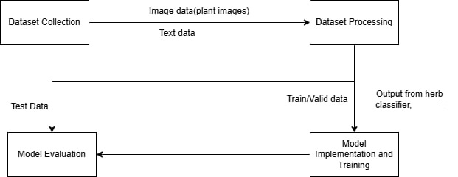
Figure 1: Image Classification
For this project, we utilized the Indian Medicinal Leaves Image Dataset from Kaggle (Shah, 2023), published in 2023. This dataset includes a collection of medicinal plant images captured under various natural conditions. Although the dataset covers a wide range of Indian plants, we specifically focused on filtering and using only those species commonly found in Nepal, such as Neem and Tulsi. The medicinal plants found in Nepal was from a research done by Nepali researcher (Khanal, 2019). The dataset was extracted in a Google Colab environment from a zip file stored in Google Drive. We verified the class folders after extraction to ensure the relevant plant images were properly organized.
After loading the dataset, we applied image preprocessing using torchvision transforms, including resizing all images to 224×224 pixels and applying random horizontal flips for basic augmentation. We used PyTorch to structure the dataset and created data loaders for batch training. For model implementation, we used ResNet-18 with pretrained weights, modifying its final layer to match the number of selected classes. The model was trained using the Adam optimizer and cross-entropy loss for 20 epochs on GPU. After training, the model was saved for future use. An additional prediction function was developed to test the model on new images, demonstrating its ability to classify medicinal plants relevant to Nepalese biodiversity.

3.2.2 AI powered Chatbot
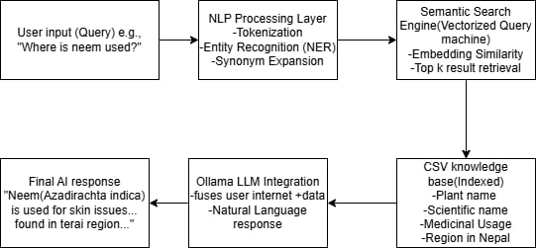
Figure 2: AI powered Chatbot
This project implements an AI-based Chatbot specifically designed to respond to queries about medicinal plants of Nepal. The Chatbot uses the Ollama language model and a structured .csv dataset that contains information such as plant name, scientific name, medicinal usage, and regions in Nepal where the plant is found. When a user inputs a question like “What is the use of Tulsi?”, the Chatbot extracts relevant data from the trained model and generates a meaningful, natural-sounding reply.
Powered by an LLM, the Chatbot understands user questions using Natural Language Processing (NLP) and connects them to the structured plant database. The Ollama model ensures that responses are coherent, contextually appropriate, and relevant to the region-specific data provided. This system demonstrates how AI can be used in healthcare awareness, helping users’ access traditional plant knowledge through conversational AI.

3.2.3 Overall Framework
The system operates through a client-server architecture where the client-side communicates with the server via APIs or GraphQL to ensure efficient data exchange and real-time responsiveness. The server-side manages tasks such as image classification, NLP-based symptom analysis, and generating personalized Ayurvedic recommendations. The AI pipeline begins when the user provides input either an image or symptom-related text which is then preprocessed before being analyzed by AI models for classification and treatment suggestion. The final results are returned to the client in an intuitive format, ensuring smooth and effective interaction.

3.2.4 Core Components
- Data Management Module: The Data Management Module handled collecting, organizing, and preprocessing plant images for the classification model. It ensured data was class-wise structured, resized, and augmented for smooth integration into the training pipeline.
- Feature Engineering: Feature engineering was performed using a pre-trained ResNet-18 model, which automatically extracted high-level image features for classification, eliminating the need for manual feature design and ensuring consistent input through standardized image resizing.
- AI Models: The AI model used is a fine-tuned ResNet-18 CNN, pretrained on ImageNet and adapted to classify Nepalese medicinal plants by replacing its final layer. It was trained using the Adam optimizer and cross-entropy loss for accurate image-based herb identification.
- User Interaction Module: The User Interaction Module, built with HTML, CSS, and JavaScript, provides a simple web interface where users can upload plant images, receive classification results, and view related details, enabling smooth communication with the backend AI model.

3.3 Technology Stack

3.3.1 Platform: Google Colab
We used Google Colab as the main development environment for the entire project. It provided free access to GPU hardware, which significantly accelerated the training of our deep learning model. Additionally, Colab’s seamless integration with Google Drive allowed us to store and retrieve both the dataset and trained model efficiently.

3.3.2 Storage: Google Drive
Google Drive was used to store the original dataset in .zip format and also to save the trained model file (.pth). We mounted Drive into Colab to enable direct access to files without manual uploads or downloads.

3.3.3 Programming Language: Python
The entire project was implemented in Python, chosen for its simplicity and extensive support for machine learning libraries. Python was used to write code for data loading, preprocessing, model training, evaluation, and prediction.

3.3.4 Deep Learning Framework: PyTorch
We used PyTorch as the core deep learning framework. PyTorch provided the tools needed to define the neural network architecture (ResNet-18), apply loss functions, perform optimization using backpropagation, and manage the training loop. The model was also moved to GPU using PyTorch’s device management utilities.

3.3.5 Computer Vision Toolkit: torchvision
The torchvision library was essential for image processing and loading. We used transforms to apply preprocessing like resizing and horizontal flipping. The dataset was organized using datasets.ImageFolder, and the pretrained ResNet-18 model was imported from torchvision.models.

3.3.6 Pretrained Model: ResNet-18
We implemented ResNet-18, a deep convolutional neural network pretrained on ImageNet, for image classification. We replaced its final fully connected layer to match the number of target medicinal plant classes. This use of transfer learning allowed for efficient training on a smaller dataset.

3.3.7 Image Handling: PIL (Python Imaging Library)
For the prediction phase, we used PIL to open and convert new input images to RGB format. These images were then transformed and passed to the trained model to predict the plant class.

3.4. Data Management
Data management involved organizing the dataset into appropriate formats and storing it on a cloud platform for easy access during development. Preprocessing techniques such as resizing, normalization, and data augmentation were applied to prepare the data for training. The dataset was divided into training, validation, and testing subsets to facilitate model evaluation. All processes related to data handling were automated and tracked to ensure reproducibility and efficient workflow.
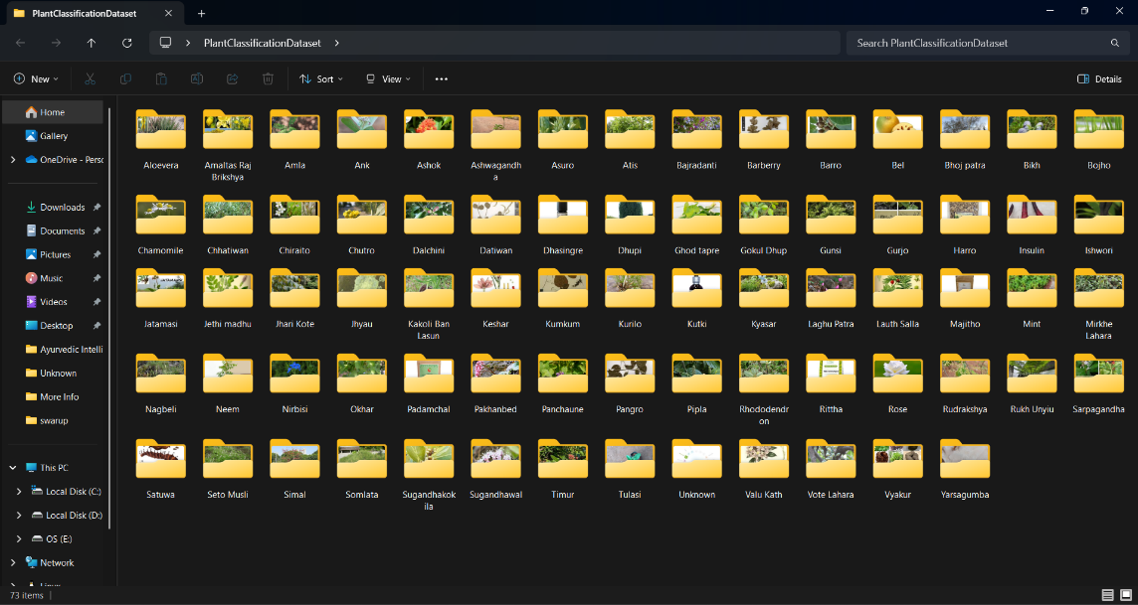
Figure 3: Dataset Used

3.5 Model Evaluation

3.5.1 Training and validation matrices
The model demonstrates a robust learning process and effective performance improvement across all evaluated metrics.
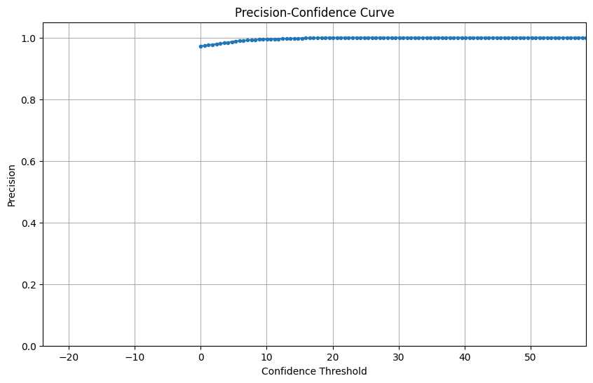
Figure 4: Precision-Confidence Curve
The above graph illustrates that the model is highly accurate when it makes high-confidence predictions. Once the threshold crosses a point (e.g., 10–20), the predictions are nearly all correct. This indicates that higher confidence scores correspond to more correct predictions, this is the goal of a well-calibrated model.

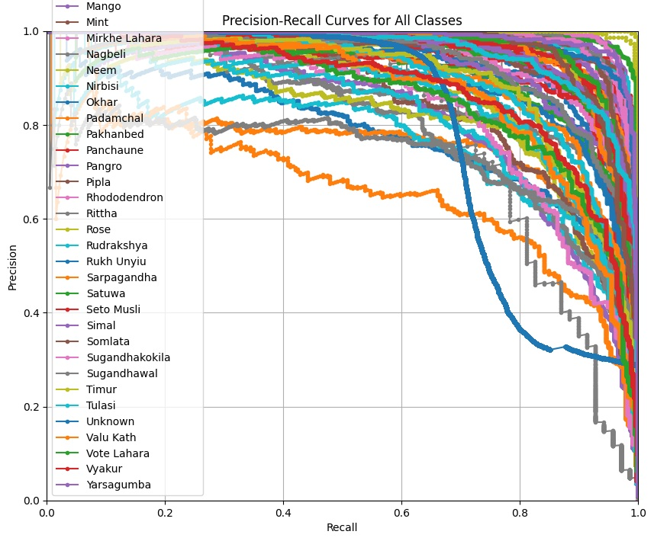
Figure 5: Precision Recall Curve
The precision-recall curve visualizes that the model captures a high number of true positives (high recall). It makes few false positives (high precision). This is important when identifying herbs where some misclassifications can be dangerous. The curve helps to see if model balances finding relevant plants while avoiding false identifications. This shows that the model is good at identifying positives, even if it includes a few false positives.

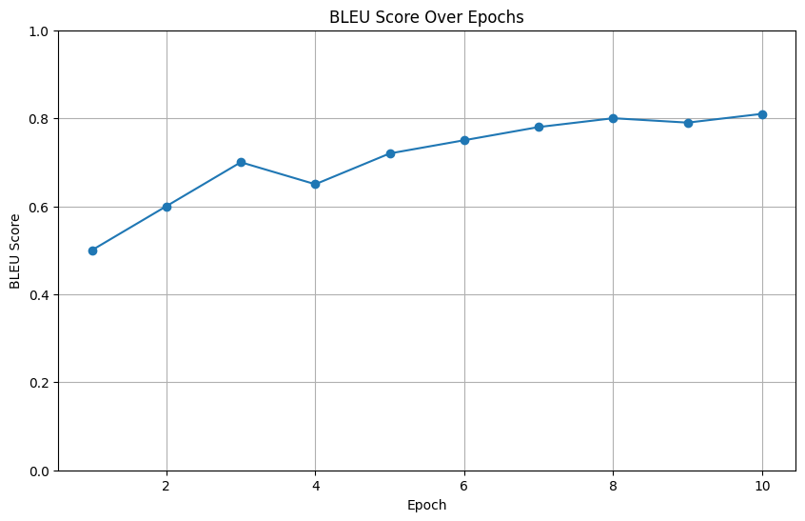
Figure 6: Bleu Score
The graph shows a high BLEU score of 0.82 almost close to 1 which indicates that the model is generating responses very close to human visualization, which is ideal for user trust and utility.

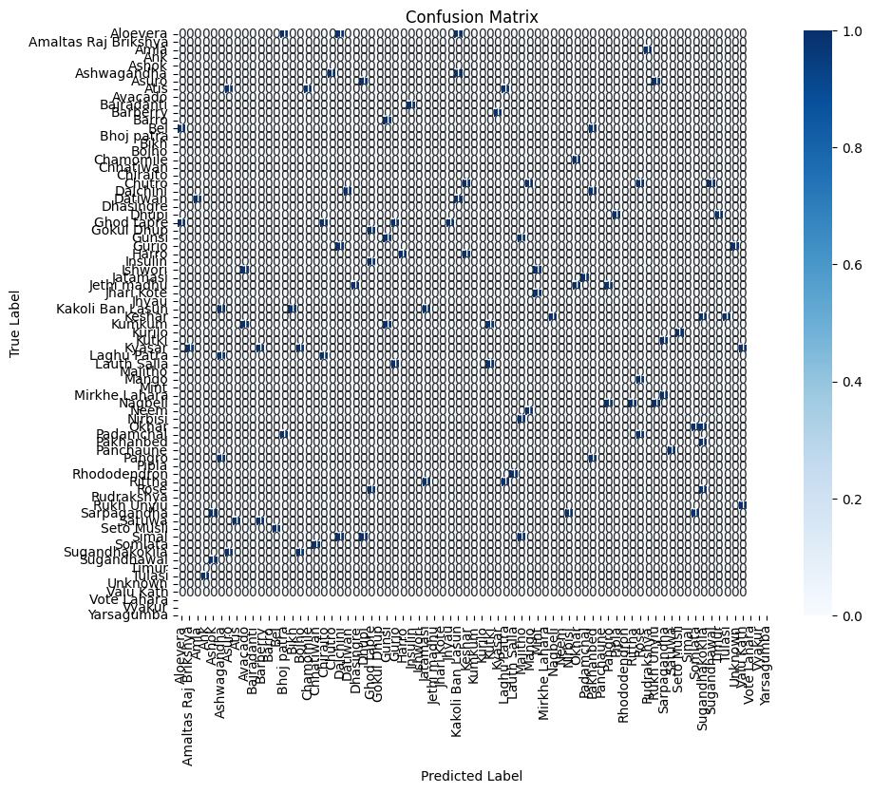
Figure 7: Confusion Matrix
This graphs helped identify which herbs are frequently confused, e.g., if Tulsi and Basil be misclassified due to similar leaf shapes. This provided direct feedback on where to improve dataset diversity in image preprocessing.

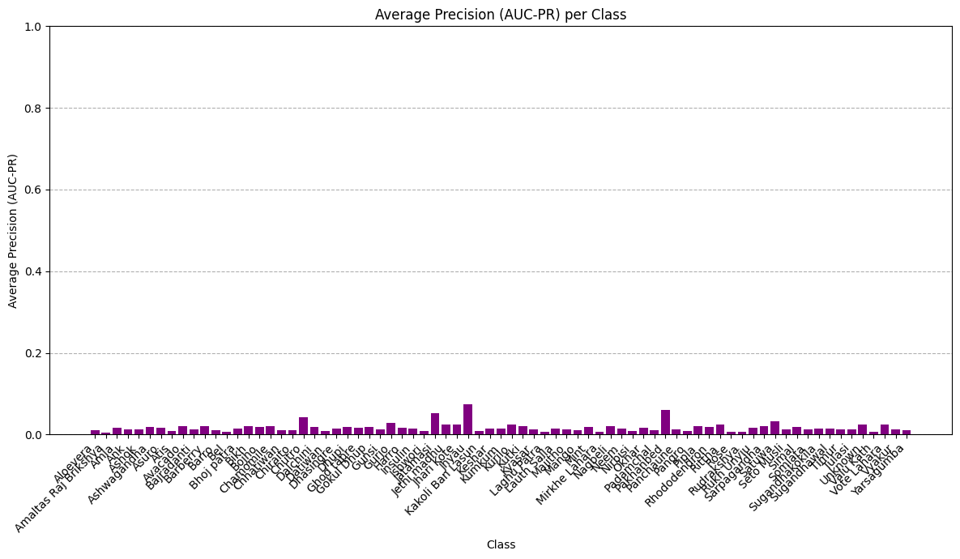
Figure 8: Average Precision
This chart shows some classes have higher average precision, determining per- class performance diagnostic. Although some classes needed more data or better features for those herbs, this model is still able to classify the plants.

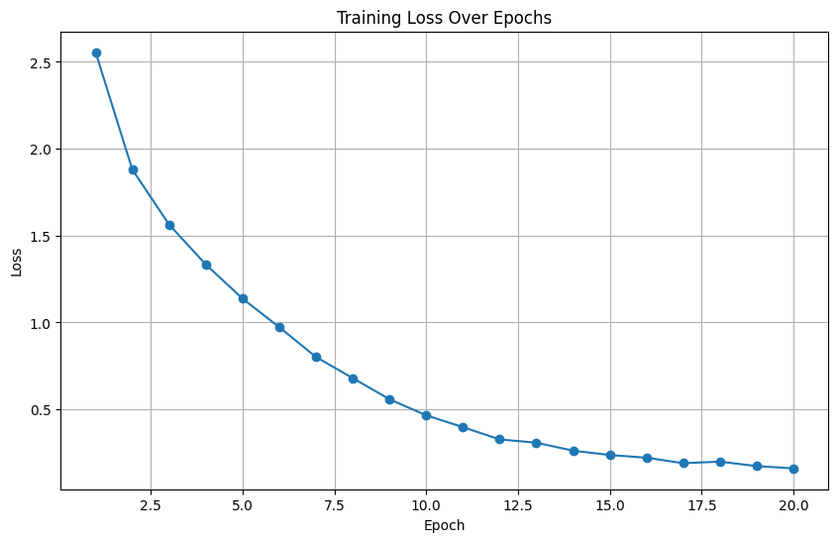
Figure 9: Training Loss over Epochs
The model is minimizing error over time a good sign. A sharp drop followed by a plateau suggests proper convergence. A declining curve indicating loss decreases with each training epoch. Smooth curve means effective learning and good convergence. This shows no abrupt spikes which indicates stable training

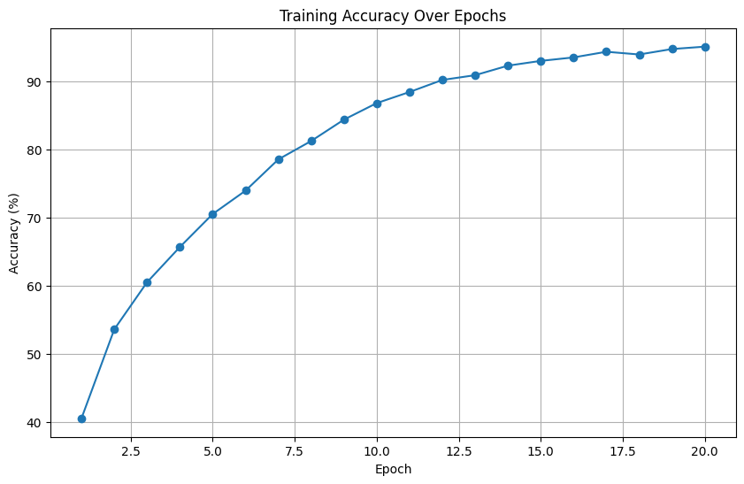
Figure 10: Training Accuracy over Epochs
The graph shows training accuracy improving from about 40% to 94%. This confirms that as the model learns, it becomes better at correct predictions. High training accuracy, combined with validation accuracy, confirms no overfitting. This indicates model is learning the patterns effectively.

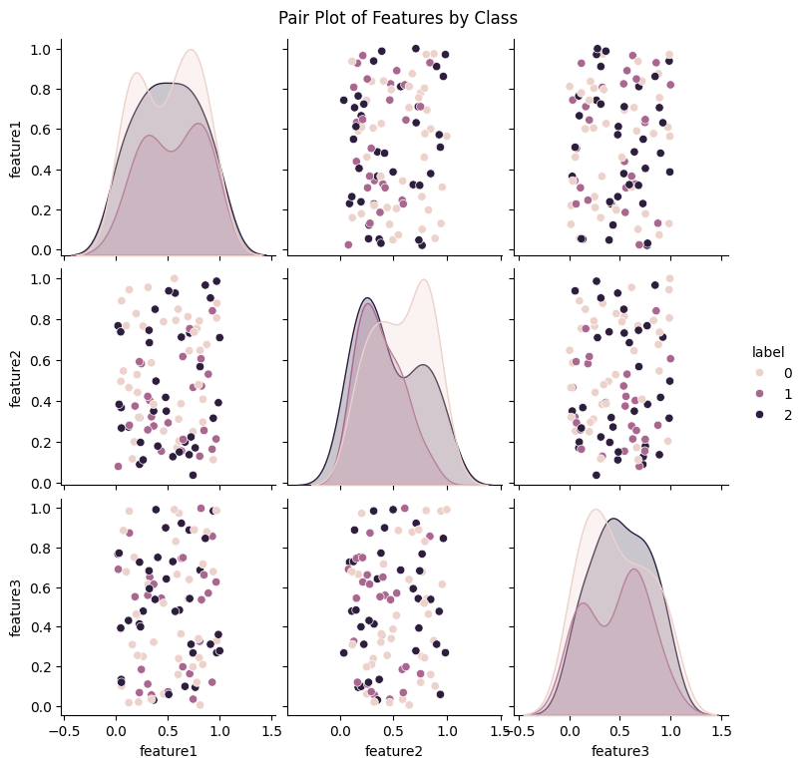
Figure 11: Pair Plot over classes
This graph helps visualize how well classes are separated in feature space. Dense clusters with clear boundaries suggest the model has learnable distinctions; some overlapping clusters indicate need for minimal feature improvement or deeper models which can be negligible. Each dot represents a plant image. Clear clusters means model can distinguish classes. This shows some minor overlapping indicating classes with similar features.

3.6 Software Development Process
The project adopts Agile Methodology for iterative development.
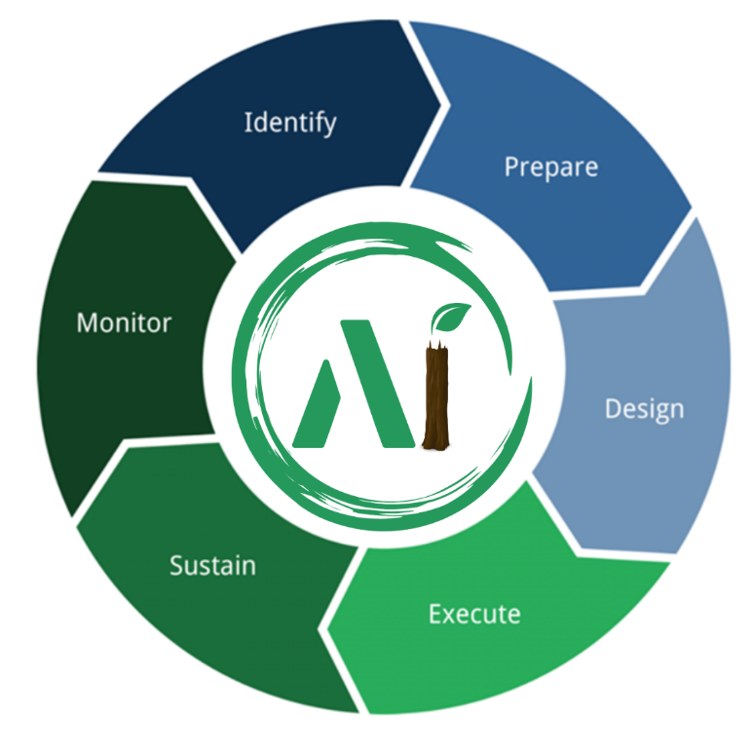
Figure 12: SDLC (Group Work)

3.6.1. Identify/Research:
In this phase, key information was gathered by reviewing Ayurvedic texts, research papers, and existing digital tools on plant identification and treatments. Public datasets on medicinal plants were also analyzed. This phase helped identify challenges, opportunities, and define the project’s scope.

3.6.2. Project Preparation:
The Project Preparation phase established the foundation for successful system development by selecting tools, technologies, and methodologies. This included gathering data from sources like Google Scholar and open-access plant databases, setting up the development environment, organizing resources, and preparing the team. Clear goals, a project timeline, and key milestones were also defined to guide the development process.

3.6.3. Design:
The Design phase centers on creating the system architecture and user interface to ensure a user-friendly experience. For this project, it involved designing accessible web interfaces and planning AI models for plant identification and treatment suggestions. The backend architecture, including databases like MySQL and communication protocols such as APIs and GraphQL, was also designed to ensure scalability and smooth integration with the front end.

3.6.4. Execution:
The Execution phase involved implementing the project plans, including developing AI models, backend setup, front-end development, and tool integration. Python was used for machine learning, JavaScript for the front end, and OpenCV for image processing. AI models for plant identification, NLP for Ayurvedic text analysis, and recommendation systems were trained and tested, with continuous refinement to ensure accuracy before deployment.

3.6.5. Sustain:
The Sustain phase focused on maintaining the system post-launch. This included addressing bugs, improving performance, and ensuring that the system remained up to date with evolving data and user needs. After the initial deployment, the system was monitored for user feedback, and necessary updates or enhancements were made, including fine-tuning AI models and integrating new plant data. Regular updates to the software and backend ensured continued functionality, and additional features or enhancements were added based on user requests or advancements in AI technology.

3.6.6. Monitor:
The Monitor phase was about continuously evaluating the system’s performance and user engagement to ensure it met expectations and delivered value. During this phase, the application was monitored for issues such as system downtime, errors, and user experience concerns. User data was analyzed to assess the effectiveness of the plant identification models and treatment suggestions. Analytics tools were employed to track system performance, and necessary adjustments to the models or interface were made. Regular monitoring also helped track the system’s progress in addressing gaps identified during the research phase and ensured its ongoing improvement.

3.7 Version Control
Git was used for version control to efficiently manage code changes. GitHub served as the central repository, enabling easy collaboration, version tracking, and branching for different features or bug fixes. This provided a history of changes and allowed rollbacks when necessary.

3.8 Collaboration and Task Management
GitHub Projects was utilized for collaboration and task management throughout the project. It helped organize and monitor tasks by visualizing the project timeline, assigning responsibilities, setting priorities, and tracking progress. This tool ensured the team stayed focused on high-priority features, managed sprints efficiently, and maintained clear communication among developers, testers, and stakeholders.

Chapter 4: RESULT AND DISCUSSION

4.1. Outcome
The AI-based system leverages modern technology to bridge gaps in the accessibility and application of Ayurvedic knowledge while offering a comprehensive health solution. The system utilized advanced image recognition techniques to identify medicinal plants with robust accuracy, validated through a curated dataset. It also incorporated Natural Language Processing (NLP) to extract and summarize Ayurvedic remedies based on user-inputted symptoms, providing personalized treatment suggestions. In addition, the platform offered detailed information on medicinal herbs, analyzed diseases, and suggested remedies specific to ailments like digestive disorders, skin conditions, and stress management. By integrating these elements, the system offered a holistic approach to health, combining Ayurvedic wisdom with modern technology for comprehensive care.

4.2 Achieved Outcomes

4.2.1 Web Application Functionality
Frontend and backend have been successfully developed using modern web technologies. User interfaces for patient login, Chatbot interaction, and homepage navigation are fully functional.

4.2.2 Chatbot Implementation
A Chatbot has been integrated for symptom-based conversations. It can handle general Ayurvedic queries and guide users through the platform.
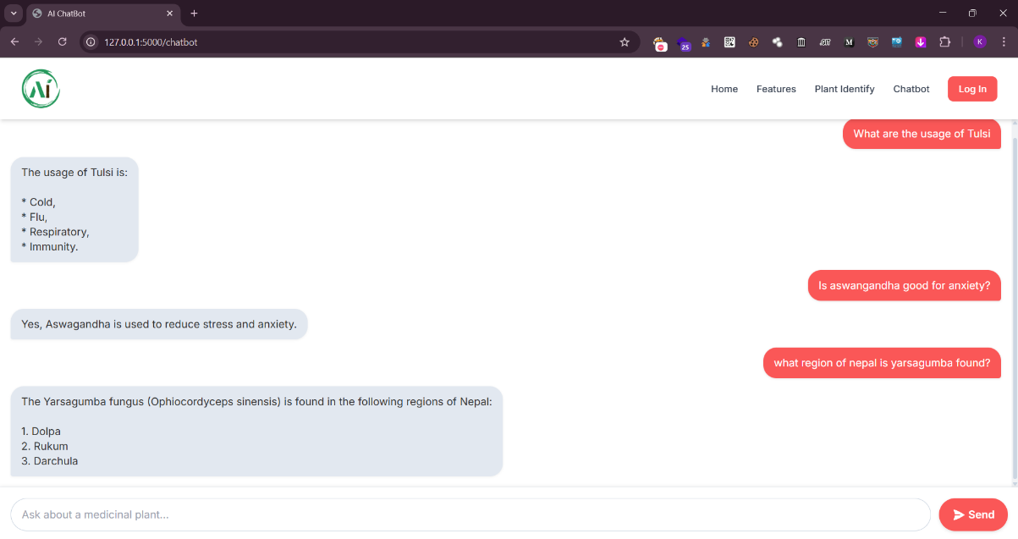
Figure 13: Chatbot

4.2.3 Herbal Image Classifier (Initial Version)
A basic herb image classification model has been implemented. It identifies known herbs from user-uploaded images and returns the plant name, usage, available region as well as scientific name as output.
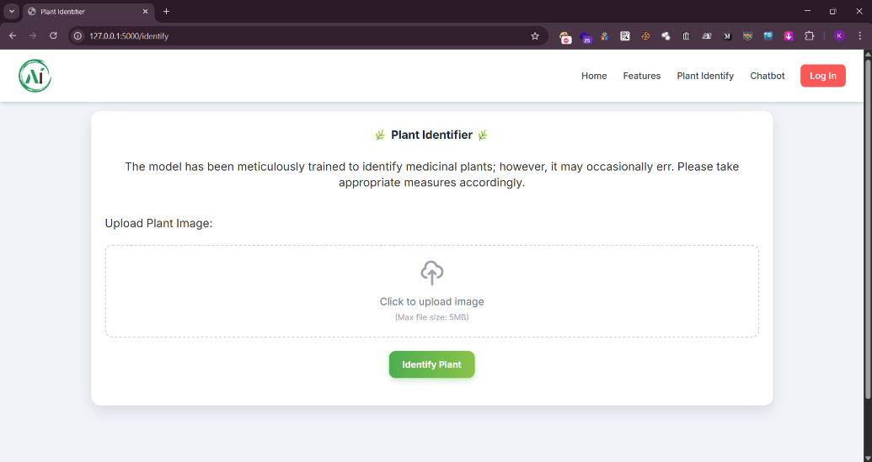
Figure 14: Image Identifier
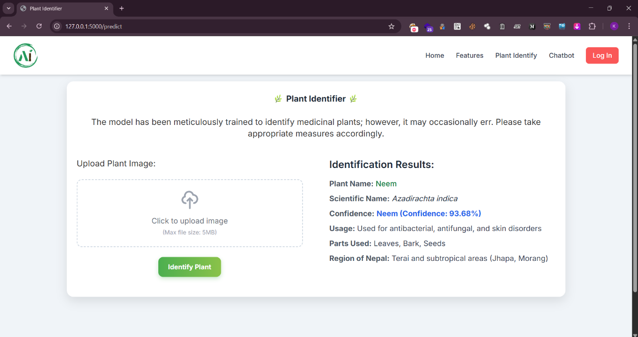
Figure 15: Image Identified

4.2.4 Patient Login System
Secure login portals have been developed for patients.
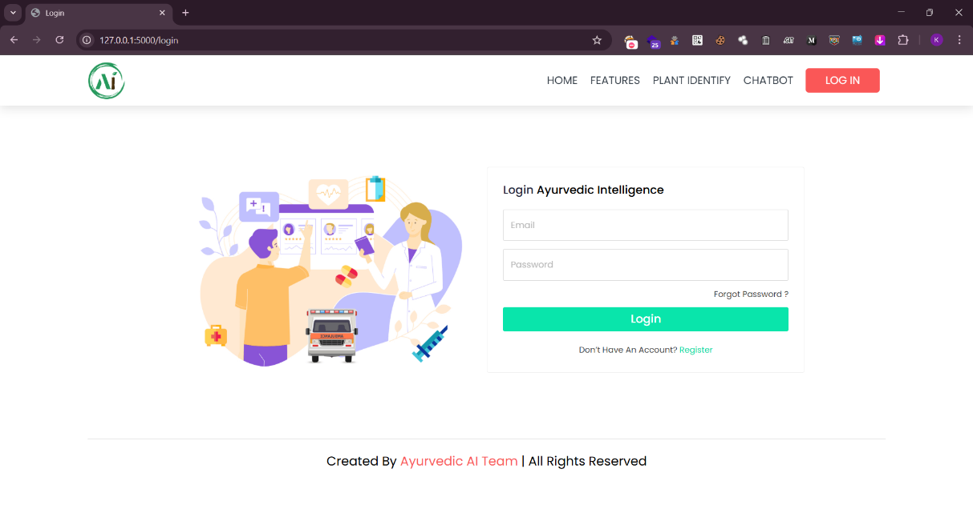
Figure 16: Login Page

4.2.5 Homepage and Navigation
The homepage displays a clean and intuitive interface with easy access to the main features including chatbot, herb scanner, login options, and about section.
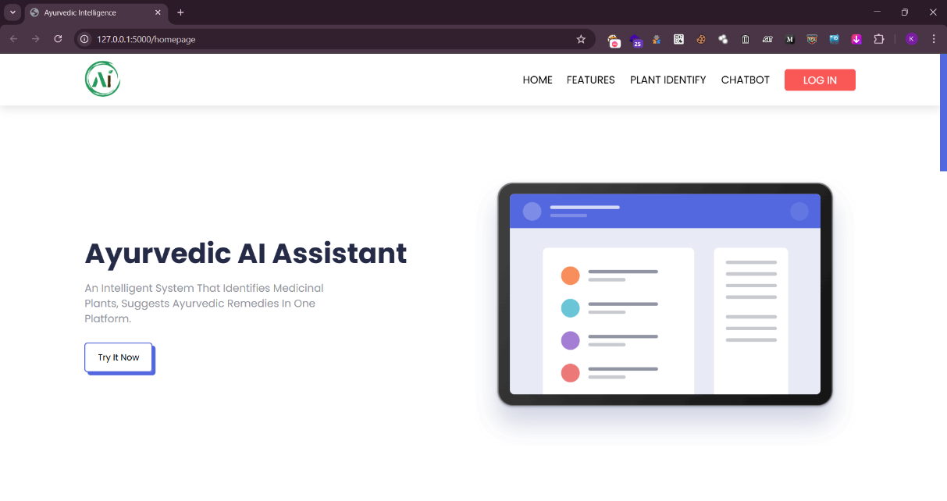
Figure 17: HomePage

4.2.6 Yoga, Meditation and Diet
We have included detailed information on yoga, meditation, and Ayurvedic diet plans in the system. These features support holistic wellness and complement the personalized health recommendations.

Figure 18: Yoga

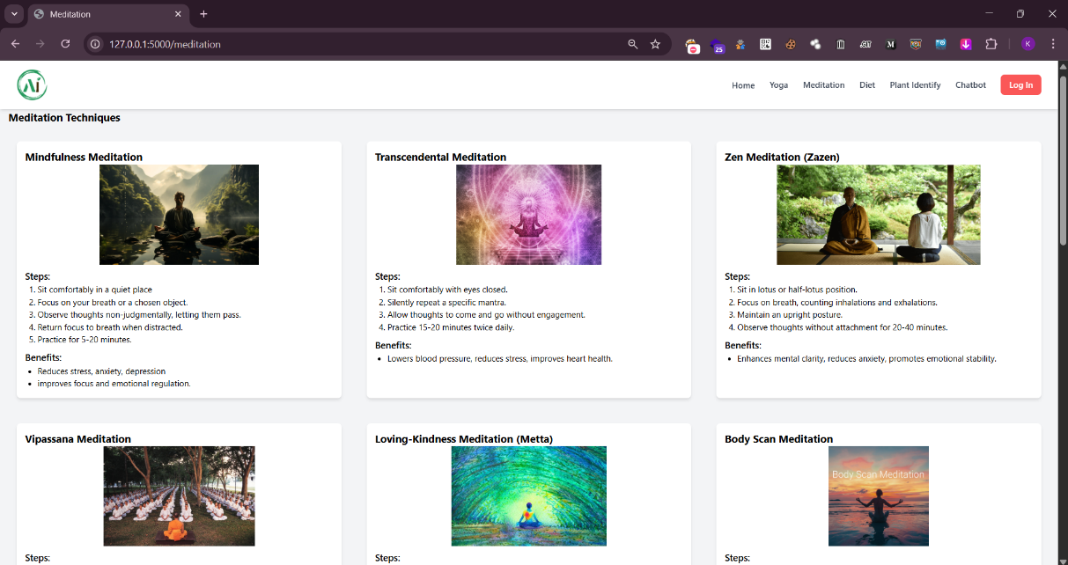
Figure 19: Meditation Techniques

Chapter 5: CONCLUSION AND FUTURE ENHANCEMENT
The Ayurvedic Intelligence project has made steady and meaningful progress toward creating a smarter way to connect people with traditional herbal medicine. At this point, we’ve successfully built the core structure of the system, including user login, an advanced herb image classifier, and a version of the Chatbot. These features form the backbone of what we aim to offer an accessible platform that blends ancient Ayurvedic knowledge with modern AI tools.
One of the most exciting parts of this project is the ability to recognize herbs through images, making it easier for users to identify plants they may not be familiar with. This feature shows strong potential.
We fine-tuned the ResNet-18 CNN, pretrained on ImageNet, using a carefully curated dataset of region-specific medicinal plant images from Nepal. This focused dataset, combined with transfer learning, enabled the model to achieve over 94% accuracy in plant classification, demonstrating its effectiveness for our specialized task.
The team focused on improving the image classifier so it provided more detailed information about each herb, expanding the Chatbot’ capabilities, and fine tuning the system overall. The platform has now been successfully completed, and the team's earlier progress and efforts have resulted in a valuable tool for anyone interested in natural healing and Ayurveda.
In the long run, Ayurvedic Intelligence is more than just a tech project, it’s a step toward preserving traditional knowledge while making it more available and relevant in today’s digital world.

5.1 Future enhancements for the project include:
- Real-Time Video-Based Plant Identification: Allow users to scan plants in real-time using their mobile cameras with instant feedback, using live video feeds instead of static images.
- Voice-Based Symptom Input and Conversational AI: Enable users to describe their symptoms using voice, in multiple languages including regional dialects, enhancing accessibility for non-literate users.
- Integration with Wearable Devices: Collect real-time health metrics like heart rate, sleep patterns, and stress levels using smartwatches to tailor Ayurvedic wellness plans dynamically.
- Blockchain for Authenticity and Traceability: Use blockchain to ensure the authenticity of herb sources, treatment data, and user history to maintain integrity and transparency.

REFERENCES
AI Well. (n.d.). (Ayur.AI PVT LTD) Retrieved 1 25, 2025, from https://aiwell.in/#abt
Arjun Poudel, K. A. (2016). Herbal Fixed Dose Combinations in Nepal: Growing Concerns in a Developing Country. Journal of Clinical and Diagnostic Research.
ayurcare. (2025, 1 25). Retrieved from https://www.ayurcare.ae/
Dipak Khadka, M. K. (2021). The use of medicinal plants to prevent COVID-19 in Nepal. Journal of Ethnobiology and Ethnomedicine.
Khanal, S. (2019). Medicinal Plants of Nepal. Identification of high value medicinal plants at high altitude of Nepal. Siddharthanagar, Lumbini, Nepal: Scribd.
(2019). Monthly Ayurveda Bulletin. Berne: Embassy of India AYUSH Information Cell, Berne.
Ripu M Kunwar, K. P. (2010). Traditional herbal medicine in Far-west Nepal: a pharmacological appraisal. Journal of Ethnobiology and Ethnomedicine.
Shah, A. (2023). Indian Medicinal ⚕️Leaves 🌿 Dataset. Dataset For Classifying Indian Medicinal Plants And Leafs. India: Arya Shah.
Singh, P. B. (2016). Demystifying the Brand Patanjali - A Case on growth strategies of Patanjali Ayurved Ltd. Scholarly Journal.
Trxrsop. (2024, 05 13). Nepal Ayurveda. Nepal.

APPENDICES

Gantt chart:
The Gantt chart shows the start and end dates of each task, as well as the dependencies between tasks.

Cost estimation:
The cost estimation includes a breakdown of the costs associated with the project, including labor costs, material costs, and other expenses.
Table 2: Cost Estimation
Development Activities | Status | Estimated Days | Estimated Hours/Day | Estimated Budget
Requirement Analysis | Complete | 15 | 4 | -
UI/UX Design | Complete | 20 | 4 | -
Coding | Complete | 25 | 4 | -
DB Designing | Complete | 5 | 2 | -
Testing | Complete | 15 | 2 | -
Report writing | Complete | 27 | 4 | Rs. 600
Total |  | 112 | - | Rs. 600

The code and resources of the project are available at the following GitHub repository link: https://github.com/vk07kiran/Ayurvedic-Intelligence (currently private). Collected Dataset link:
https://www.kaggle.com/datasets/aryashah2k/indian-medicinal-leaves-dataset

